##### Flipping Wall Calendar

##### 

**Price: Rs.700/-**

Wall Calendar Available in different sizes and colors.

Beautiful, well-made Calendars are must. We take great care in selecting our products Korea and Japan in particular is where most of the stuff we offer is designed and manufactured. All our products are made with care and use high quality, non-toxic materials.

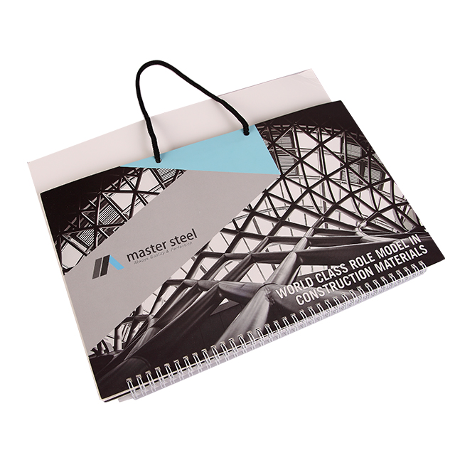

* Model Number: 20785856119
* Type: Printing Calendar
* Promotional: No
* Style: Wall Calendar
* Display Screen: show as the picture
* Use: Plastic calendar
* Origin: turkey
* Color: white ,blue, black.
* Size: 6.5cm x 12cm x1cm
* Type 1: Wall Calendar
* Type 2: Pages Calendar